ADK (Python Programming) ROLL NO : 04

Aim: Write the program for the following: (by using control statements and control structure)
(F). Write a recursive function to print the factorial for a given number.
Theory: -
Practical Implementation:-
# python program to find the factorial of a number using recursion

def recur_factorial (n):
"""function to return the factorial of a number using recursion"""
if n == 1:
return n
else:
return n*recur_factorial(n-1)

# take input from the user
num = int(input("enter a number: "))

# check is the number is negative
if num < 0:
print("sorry,factorial does not exist for negative number")
elif num == 0:
print("the factorial of 0 is 1")
else:
print("the factorial of",num,"is",recur_factorial(num))

output:-
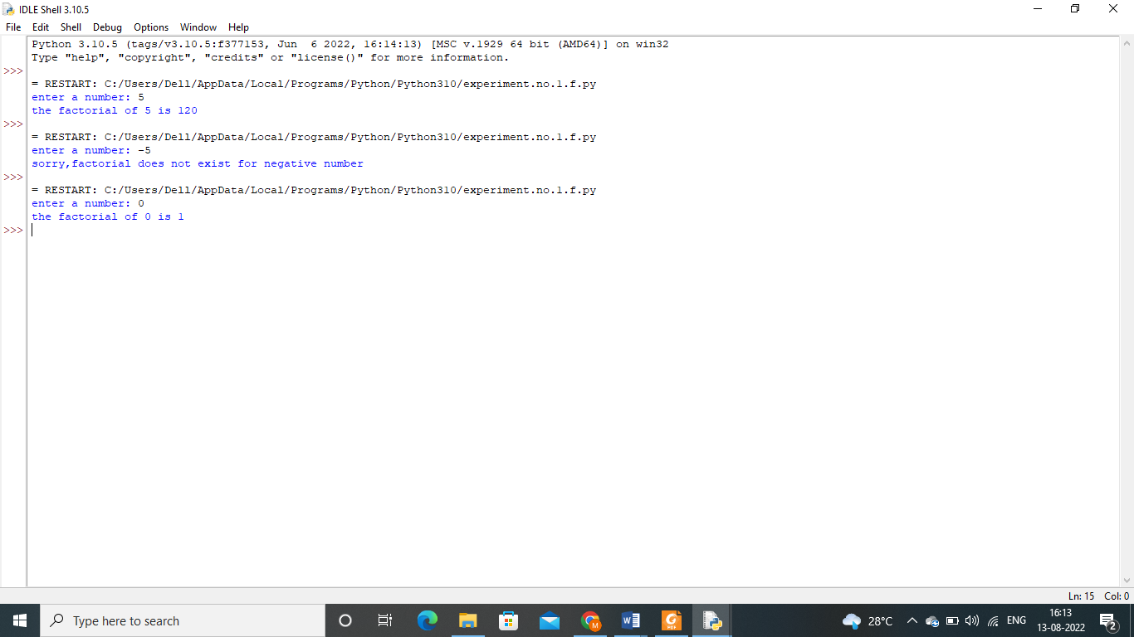
Conclusion:-

